**Indian Institute of Engineering Science & Technology, Shibpur**

**Department of Computer Science & Technology**

**8th Semester Artificial Intelligence Laboratory 2025**

**CS 4271**

**ASSIGNMENT – 4**

1. Connect-4 is a strategic two-player game where participants choose a disc colour and take turns dropping their coloured discs into a seven-column, six-row grid.



Victory is achieved by forming a line of four discs horizontally, vertically, or diagonally. Several winning strategies enhance gameplay:

1. **Middle Column Placement:**

The player initiating the game benefits from placing the first disc in the middle column. This strategic move maximizes the possibilities for vertical, diagonal, and horizontal connections, totalling five potential ways to win.

1. **Trapping Opponents:**

To prevent losses, players strategically block their opponent's potential winning paths. For instance, placing a disc adjacent to an opponent's three-disc line disrupts their progression and protects the player from falling into traps set by the opponent.

1. **"7" Formation:**

Employing a "7" trap involves arranging discs to resemble the shape of a 7 on the board. This strategic move, which can be configured in various orientations, provides players with multiple directions to achieve a connect-four, adding versatility to their gameplay.

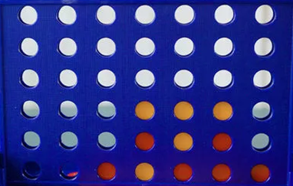

**Connect-4 Implementation using Mini-Max Algorithm:**

In this scenario, a user engages in a game against the computer, and the Mini-Max algorithm is employed to generate game states. Mini-Max, a backtracking algorithm widely used in decision-making and game theory, determines the optimal move for a player under the assumption that the opponent also plays optimally. Two players, the maximizer and the minimizer, aim to achieve the highest and lowest scores, respectively. A heuristic function calculates the values associated with each board state, representing the advantage of one player over the other.

**Connect-4 Implementation using Alpha-Beta Pruning:**

To optimize the Mini-Max algorithm, the Alpha-Beta Pruning technique is applied. Alpha-Beta Pruning involves passing two additional parameters, alpha and beta, to the Mini-Max function, reducing the number of evaluated nodes in the game tree. By introducing these parameters, the algorithm searches more efficiently, reaching greater depths in the game tree. Alpha-Beta Pruning accelerates the search process by eliminating the need to evaluate unnecessary branches when a superior move has been identified, resulting in significant computational time savings.